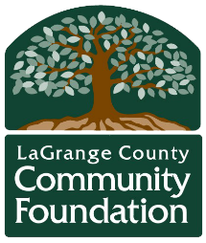
2024 LaGrange Partners Meeting Schedule

LaGrange Partners is an interagency meeting for LaGrange County nonprofit organizations and entities providing services to LaGrange County residents. LaGrange Partners provides a forum for learning about resources, discussing current issues, networking, and keeping up to date on existing services.
The meeting is open to nonprofit staff, board members, volunteers and interested community members who want to connect and learn more about the nonprofit sector in LaGrange County.
Meetings are on the second Tuesday of every other month, from 11:30 a.m. to 1 p.m. Located in the Community Room at the Foundation. The meeting format includes time for lunch, agency announcements, networking, and a featured presentation on a focus topic.
LaGrange Partners is facilitated by the LaGrange County Community Foundation. You can find meeting and resource information at: lccf.net/LaGrangePartners
Please note this meeting is FREE to attend. The cost of $15 is to purchase lunch.

Meeting Date | Topic | Location | Cost
February 13 | Early Childhood | Community Room at Foundation | $15 for lunch
April 9 | Diversity | LaGrange County Public Library, Community Room | $15 for lunch
June 11 | Restorative Wellness | TBD | $15 for lunch
August 13 | Homelessness/Food Insecurity | TBD | $15 for lunch
October 8 | Mental Health | TBD | $15 for lunch

